**Lab Matplotlib Bar Plot And Histogram(Day-23)**

**Lab1: Visualize the daily temperature changes over time in a city and give your**

**conclusion**

**Input:**

**days = list(range(1, 32))**

**# Daily temperature data (replace with your own data)**

**temperature = [65, 68, 70, 72, 75, 76, 78, 80, 81, 79, 75, 72, 70, 68, 67, 69, 70, 73, 75, 76, 78,**

**80, 81, 82, 83, 82, 80, 78, 76, 74, 71]**

**Output:**

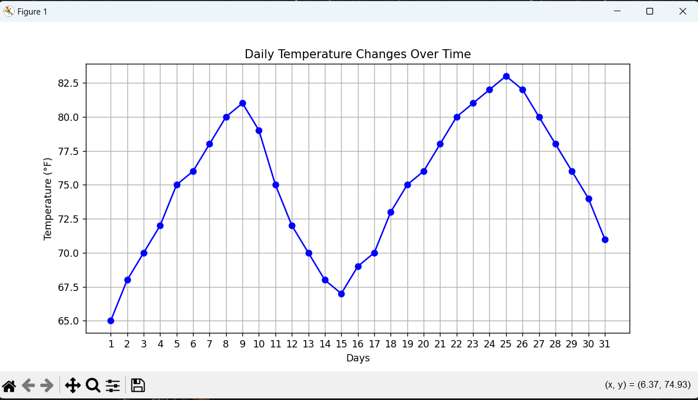

**Lab2: Create a line plot to visualize the daily closing prices of a stock over a year**

**and give your conclusion.**

**Input:**

**days = list(range(1, 78))**

**# Daily closing prices of a stock (replace with your own data)**

**stock_prices = [100, 105, 110, 115, 112, 120, 118, 125, 128, 130, 132, 135, 138, 140, 142, 144, 145, 148, 150, 155, 160, 158, 162, 165, 170, 172, 175, 178, 180, 182, 185, 188, 190, 192, 195, 198, 200, 198, 195, 193, 190, 188, 185, 182, 180, 178, 175, 172, 170, 168, 165, 162, 160, 158, 155, 152, 150, 148, 145, 143, 140, 138, 135, 132, 130, 128, 125, 123, 120, 118, 115, 112, 110, 108, 105, 103, 100]**

**Output:**

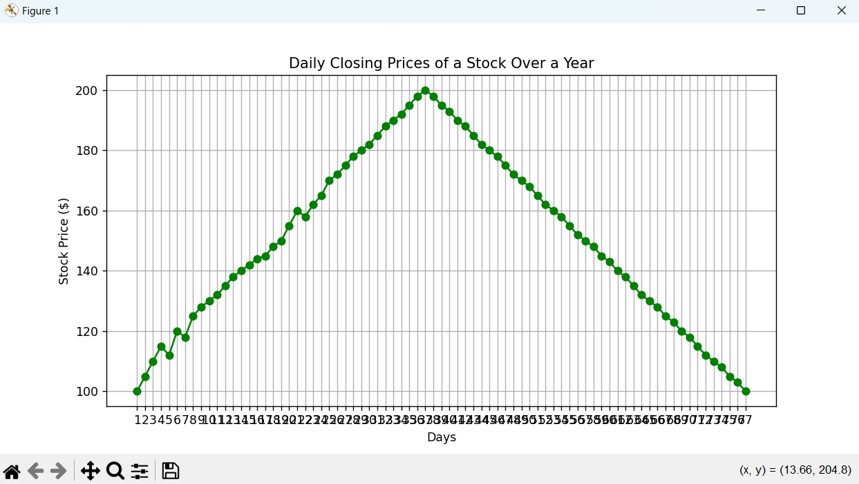

**Lab3: Create a bar chart to represent monthly expenses in different spending**

**categories and give your conclusion.**

**Input:**

**categories = ['Rent', 'Groceries', 'Utilities', 'Entertainment', 'Transportation']**

**# Monthly expenses in dollars (replace with your own data)**

**expenses = [1200, 400, 200, 150, 250]**

**Output:**

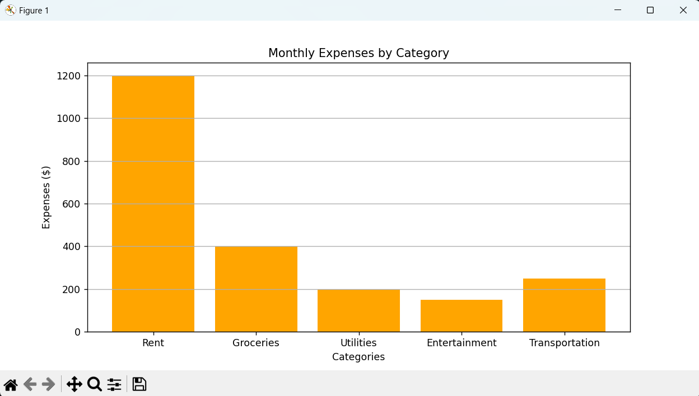

**Lab4: Create a histogram to represent the distribution of product prices in a retail**

**store and give your conclusion.**

**Input:**

**product_prices = [24.99, 34.99, 49.99, 64.99, 39.99, 54.99, 79.99, 99.99, 29.99, 44.99, 59.99, 69.99, 84.99, 109.99, 119.99, 89.99, 74.99, 124.99, 69.99, 54.99]**

**Output:**

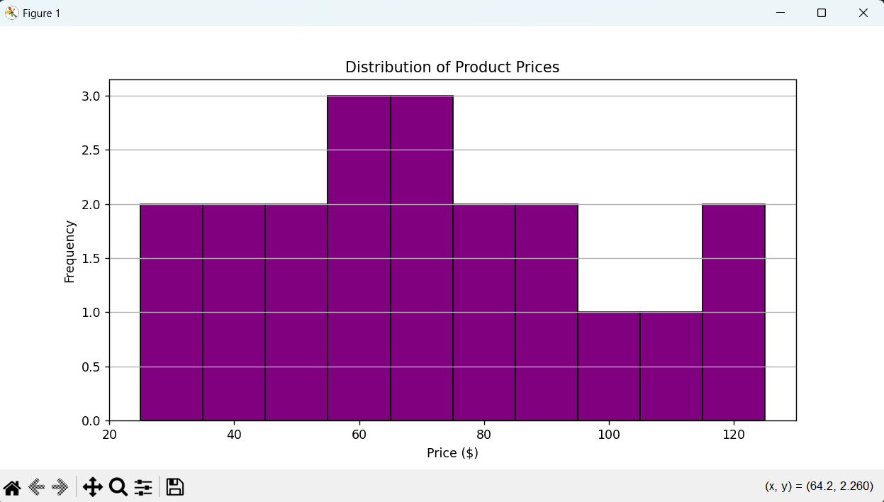

**ChatGPT Exercise**

**Using ChatGPT generate the python code to solve the same problem**

**Scenario:**

**Suppose you have two columns named regions and sales with some dummy data frame**

**and you need to generate a bar chart based on these two columns and also generate**

**the percentage.**

**Further, you need to get some inference out of the chart.**

**Create a ChatGPT prompt to generate the code for this scenario. Based on the code**

**generated, ask ChatGPT to give the conclusion/inference.**

**Note. You can provide the data to ChatGPT or ask it to use sample data.**

